**FUNDAMENTAL OF MANAGEMENT**

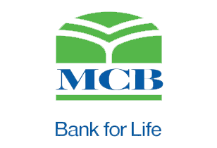

**PROJECT:**

**MCB BANK**

**Group number 2**

**Report # 03**

**Group Members:**

* Ibrar Babar (19P-0104)
* Asjid Tahir (p19-0085)
* Usman Manzoor (p19-0068)
* Umar Farooq (p19-0065)

**Management:**

The process of dealing with or controlling things or people. In general, **bank management** refers to the process of **managing** the **Bank's** statutory activity. **Bank management** is characterized by the specific object of **management** - financial relations connected with **banking** activities and other relations, also connected with implementation of **management** functions in **banking**.

**Strategies of management:**

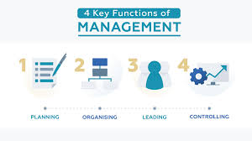Following are the main strategies of bank management:

* Improve the Digital Customer Experience.
* Enhance Data Analytics Capabilities.
* Reduce Operating Costs.
* Increase Investment in Innovation.
* Recruit and Retrain Talent.
* Improve Business Processes.

**Bank Strategy:**

Banks make money based on the total deposits maintained and loans issued. Consumers have many banks and credit unions to choose from, all competing for their checking, savings and lending needs. In highly competitive markets, banks must utilize strategies for acquiring and retaining assets from new and existing customers. Following are the main strategies:

* **Community Marketing:**

Banks range in size and capabilities. Small banks may only have one or two branch offices whereas large commercial banks may have thousands of branches across the nation. Consumers bank in a place where they feel safe and comfortable. This means tellers and account representatives who speak English as well as any prominent language in the community. By having branch managers look at the local community needs, the bank can attract a larger percentage of the target market.

* **Product Bundling:**

A successful strategy employed by all banks is product bundling, such as offering a free checking account for those who open a savings account. Because this has become common practice, successful strategies implement creative bundling solutions. An automatic home line of credit with a mortgage refinance might be a solution when interest rates are low or the community has a large percentage of consumers looking to consolidate debt.

* **Pre-Approved Products:**

Banks can review existing accounts to determine positive banking and credit trends in customers. Those identified with positive trends and credit history are sent "pre-approval" letters for credit cards, lines of credit or mortgages.

* **Teller Referrals:**

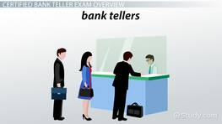Bank tellers interact with the majority of the bank clientele. Tellers perform the day-to-day transactions, such as cashing checks, making deposits or transferring money. Successful banks consistently train tellers to look for opportunities to cross-sell bank products and refer customers to the right person.

* **Premier Services:**

Premier services are designed to attract high net worth bank clientele. High net worth clients often have different needs as well as expectations. By offering a select set of private bankers to personally handle all transactions and account reviews, client trust increases.

**Marketing Strategies For promoting Bank:**

Banks have a unique challenge when it comes to marketing because they do not offer tangible products for consumers. Promoting a bank requires convincing consumers to trust a bank with their money and make customers feel like they are getting the most value for their money.

## **Word of Mouth**

Word of mouth has the greatest potential to attract customers to a bank and draw customers away from a bank. Become involved in the community by sponsoring a local sports team, setting up a booth at a local festival or providing a mobile ATM machine for a local event. Be sure to provide stellar customer service to all current users because a customer sharing a negative experience about the bank may quickly erase the effect of any positive marketing efforts in a community.

## **Credit Cards**

Offer specialized credit cards for consumers, such as cards designed for college students, small-business owners or mature bankers. Cards with low interest rates and few fees typically attract more customers. A card that offers rewards or a cash-back program may also appeal to consumers. Offer a line of prepaid debit cards, and encourage parents to set up accounts for their children or allow teens to become authorized users on a parent's credit card.

## **Incorporating Technology**

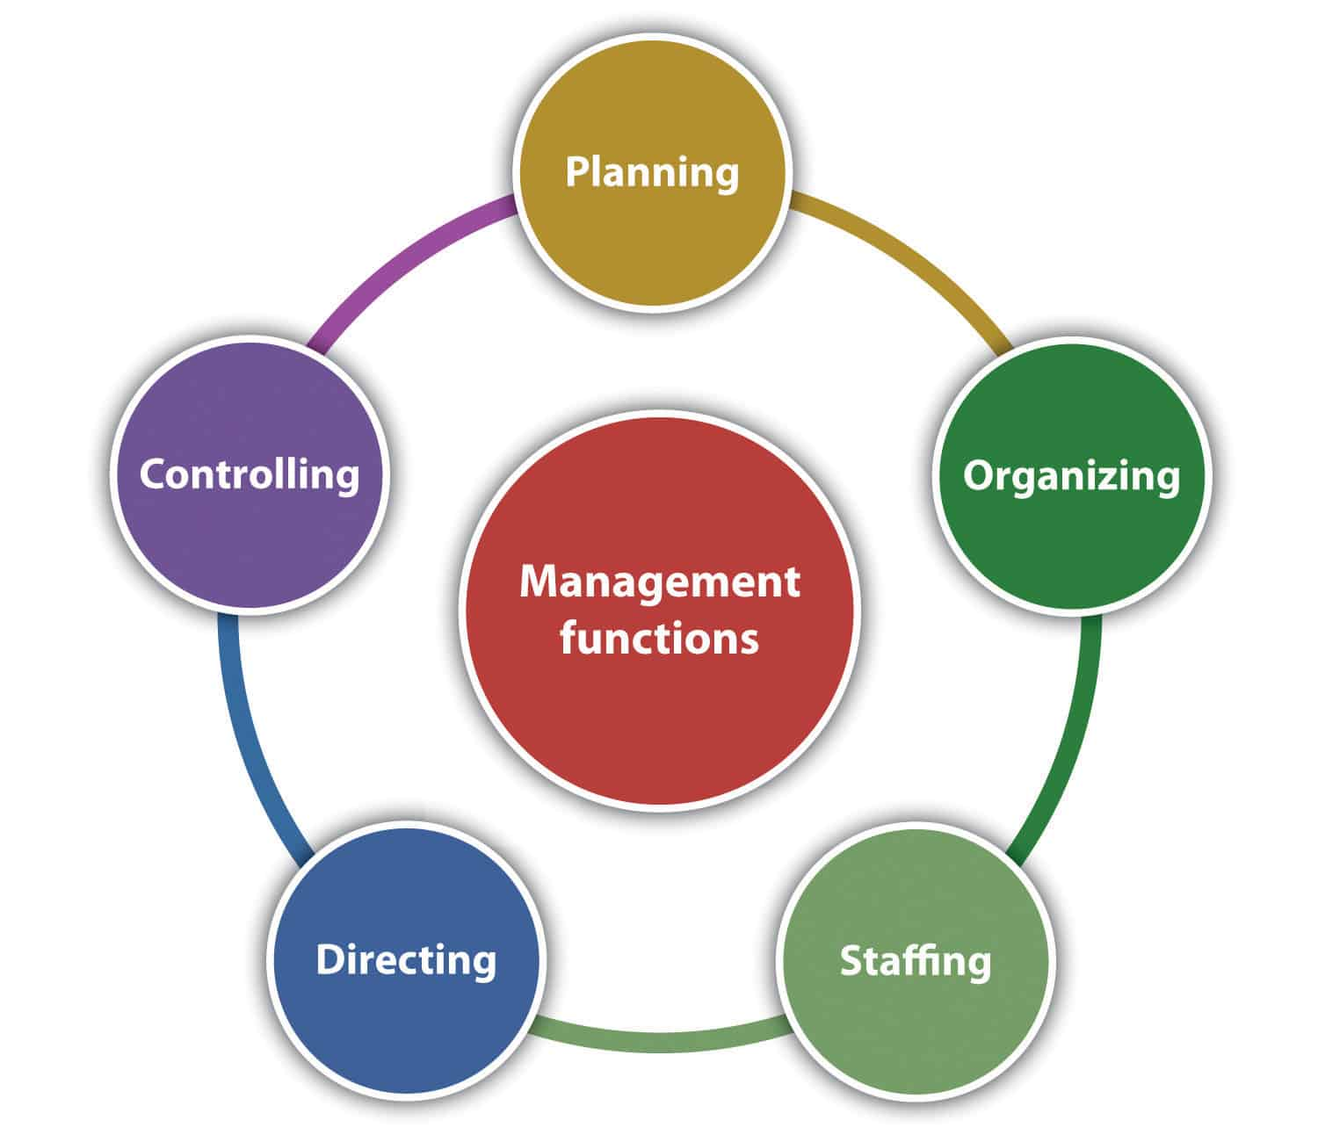With the popularity of the Internet and smartphones, many customers have turned to doing the majority of their banking online. Update your bank's website to make it easy to navigate, and allow users to transfer money and view account information from multiple locations. Include descriptions of all products on your website to give potential customers the information they need to make a decision.

**Increase revenue for Retail bank:**

Traditional sources of revenue from mass-market products such as loans, credit cards and mortgages has proved difficult in view of consumer caution and a tightening regulatory environment. Instead, retail banks are targeting customer groups with the greatest growth potential, developing new products and services for those groups, and improving standards of customer service.

## **Information**

Banks hold large amounts of data on their customers, but do not use the data effectively to identify new revenue opportunities, according to the Boston Consulting Group. The consultancy recommends using data to gain a better understanding of individual customers’ needs as a basis for customizing products and levels of service to meet those needs

* **Profile**

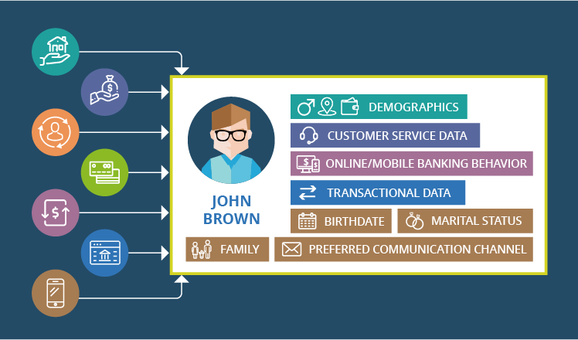Retail banks can employ database technology to create customer profiles that sales and customer-service staff can use to increase revenue and strengthen customer relationships, according to IBM..

## **New Products**

In the current financial climate, consumers remain cautious about taking financial risks, preferring to protect their assets.To deliver that service and maximize revenue potential, banks are acquiring investment companies or expanding their own investment activities

## **Customer Technology**

Retail banks aim to grow revenue by expanding their customer base, particularly in the younger age group. According to Cisco Systems, the requirements of younger consumers will provide the next major revenue opportunity for retail banking. As a result, banks are developing technology-based services that are aligned to the lifestyles of their younger consumers. Among early initiatives are mobile banking services for smartphones, real-time text alerts on account status, and video links to financial advisers.

## **Employee Culture**

Training and motivating branch staff to sell products and services to customers is an important factor in growing revenue. Branch staff have an existing relationship with customers, but that relationship has traditionally been based on service rather than sales. By providing branch staff with product information, profiles that identify customers’ product needs, and incentive programs to encourage selling, banks can use existing relationships to increase revenue per customer.

**Marketing segments for banking industries:**

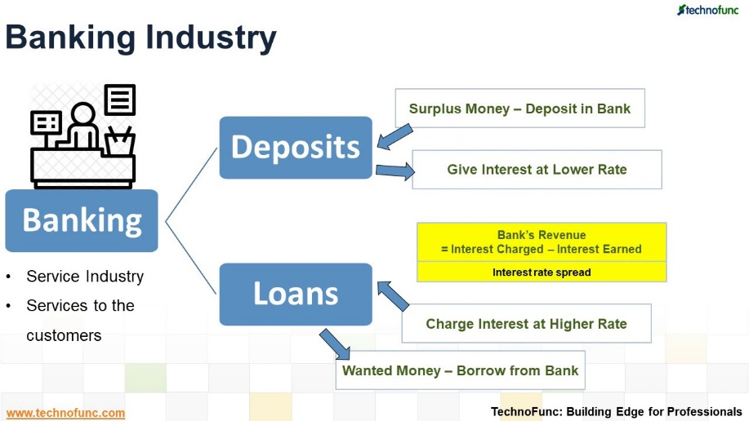Market segmentation is a common marketing practice that means breaking down a larger target market into smaller, more manageable market segments to improve marketing efficiency, sales and service. Several common segmentation strategies exist. While small banks often service local geographic areas and demographics segmentation is often sensible, banks can often best define market segments based on product benefits when they offer multiple types of products.

## **Standard Banking**

One of the largest common benefit segments offered by a bank is for its standard checking and savings banking products. Many banks promote these basic products on their website home pages. Historically, standard checking and standard savings accounts were sold separately. However, many banks have attempted to bolster relationships with their standard banking customers by developing packages whereby customers get added value by combining a checking and savings account and often better interest rates with automatic checking-to-savings transfers. Banks often target consumers in this segment through traditional media like radio, television, newspapers and magazines.

## **High-end Savings**

High-end savings is typically a step up from the standard checking and savings customer. High-end savings products may include higher dollar value money market and savings accounts, certificates of deposits and other long-term savings products intended to derive great monetary value from customers. These products are sometimes marketed through traditional means, but they are also often marketed to existing standard customers who may have interest in moving up in savings value at some point.

## **Loans**

For many banks, loans are a huge segment of banking operations. Home loans and auto loans make up a significant portion of bank lending, but equity loans, student loans and personal loans are also common. Loan products are typically advertised separately from the bank's other products. Banks may promote home loans through local real estate publications or resources. Auto loan offers make sense in car-related media. Banks also cross promote by marketing loan products to existing banking customers and even offering better rates with bundled products.

## **Investment**

A fast-growing segment in traditional banks is in the investment product sector. Traditionally, individual investors have had to set up separate investment accounts with niche investment banks. With the evolution of the Internet in the early 21st century and many more people managing their own stock, bond and other investments, traditional banks have expanded significantly into this sector. Again, banks can market investment solutions to existing customers with bundled benefits. They can also advertise through local media, but they may deliver more targeted messages through investment-related publications.

## **Commercial Products**

Banks segment customers into two general categories before breaking down those markets into product benefits: consumers and businesses. Some companies focus entirely on consumer products; others do only commercial banking. However, many traditional banks market to both types and offer products in similar areas for businesses because of their normally larger size and scope regarding money management.

**How does a bank works??**

A bank is an institution whose primary purpose is to accept deposits and make loans, although banks may also offer a multitude of other services. A number of types of bank exists, including commercial banks, consumer banks, investment banks, central banks and international banks. Banking services that may be beneficial to your small business include depository accounts, advisory services, commercial loans and payment services.

## **Banking System**

The banking system is a dual system that includes regulation and oversight at both the state and federal level. You may notice the word "national" or "state" in a bank's name. This nomenclature has nothing to do with the bank's physical location. Instead it has to do with how the bank was chartered. National banks are charted and regulated by the Office of the Comptroller of the Currency.

* **Fees**

Banks may derive a significant portion of their income from non-interest or fee-based services for either traditional or non-traditional banking services. Fees from traditional services may include late charges on credit card payments, monthly service charges for non-interest bearing checking accounts and returned check charges. Fees for non-traditional services may include fees for insurance services, securities brokerage services and merchant banking services.

## **Ancillary Services**

You bank may offer a variety of ancillary services that can benefit your small business. Your bank may provide merchant services allowing you to offer your customers multiple payment options, such as credit cards. You may be able to set up your payroll on direct deposit through your bank..

**HrM department:**

Human resource management (HRM) has long been overlooked in the corporate sector in the country where a small section, comprising mostly the multi-national companies was practicing the same. With the growing realization of proper HRM in the corporate sector, it has grown into an important activity. The banking sector has grown from a few institutions primarily involved in deposit acceptance and trade finance into a complex multiplayer markets where large number of commercial banks, financial institutions and specialized banks are operating with various products and activities.

**Key functions of HRM:**

* Recruitment, selection, and on boarding (researching)
* Organizational design and development
* Business transformation and change management
* Training and development (learning management)
* Implementation of such policies, processes or standards may be directly managed by the HR function itself, or the function may indirectly
* Supervise the implementation of such activities by managers, other business functions or via third-party external partner organizations.

**Compensation Management:**

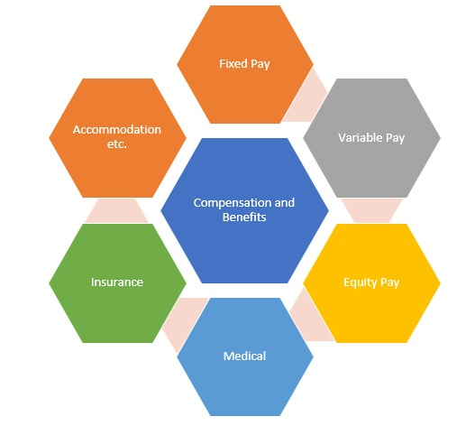Compensation Management is an integral part of the management of he organization. Compensation is a systematic approach to providing monetary value to employees in exchange for work performed. It may achieve several purposes assisting in recruitment, job performance, and job satisfaction. It is the remuneration received by an employee in return for his/her contribution to the organization.

**Components of compensation:**

**Basic wages/Salaries:-**

These refer to the cash component of the wage structure based on which other elements of compensation may be structured. It is normally a fixed amount which is subject to changes based on annual increments or subject to periodical pay hikes. They differ from employee to employee, and depend upon the nature of job, seniority, and merit.

* **Dearness allowance:-**

The payment of dearness allowance facilitates employees and workers to face the price increase or inflation of prices of goods and services consumed by him. The payment of dearness allowance, which may be a fixed percentage on the basic wage, enables the employees to face the increasing prices.

* **Incentives:-**

Incentives are paid in addition to wages and salaries and are also called ‘payments by results’. Incentives depend upon productivity, sales, profit, or cost reduction efforts.

* **Bonus:-**

The bonus can be paid in different ways. It can be fixed percentage on the basic wage paid annually or in proportion to the profitability. The Government also prescribes a minimum statutory bonus for all employees and workers. There is also a bonus plan which compensates the Managers and employees based on the sales revenue or Profit margin achieved

* **Non-monetary benefits:-**

These benefits give psychological satisfaction to employees even when financial benefit is not available. Such benefits are:

* Recognition of merit through certificate, etc.
* Offering challenging job responsibilities.
* Comfortable working conditions.
* Competent supervision.
* Job sharing and flexi-time.
* **Commissions:-**

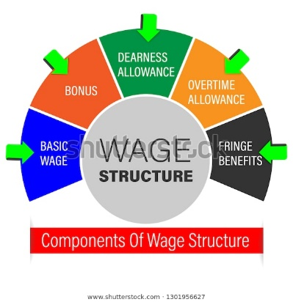Commission to Managers and employees may be based on the sales revenue or profits of the company. It is always a fixed percentage on the target achieved. For taxation purposes, commission is again a taxable component of compensation. The payment of commission as a component of commission is practiced heavily on target based sales.

* **Piece rate wages:-**

Piece rate wages are prevalent in the manufacturing wages. The laborers are paid wages for each of the Quantity produced by them. The gross earnings of the labour would be equivalent to number of goods produced by them

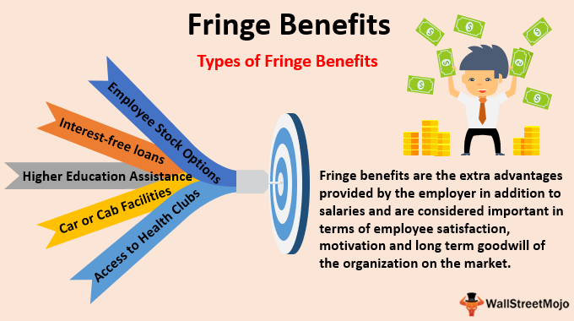**Fringe benefits:-**Fringe benefits may be defined as wide range of benefits and services that employees receive as an integral part of their total compensation package. They are based on critical job factors and performance..

* **Profit Sharing:**

Profit-sharing is regarded as a steppingstone to industrial democracy. Profit-sharing is an agreement by which employees receive a share, fixed in advance of the profits. Profit-sharing usually involves the determination of an organization’s profit at the end of the fiscal year and the distribution of a percentage of the profits to the workers qualified to share in the earnings

**Conclusion:**

Bank plays very important role in the economic development of nations as they, to a large extent wield control over the supply of money in the circulation and are the main stimuli of economic progress. The performance of bank institution and the other financial insitutions need to be evaluated because it is defined as the reflection of the way in which the resources of the bank are used in a form which enables it to achieve its objectives. As the banking sector is considered as a vital segment of modern economy, bank and other financial insitutions must be carefully evaluated and analyzed. While bank and other financial isitutions helps business organization by rendering a wide range of products and services, the product and services are more or less identical from one bank to another, and there is little scope for finding between them. Therefore, a strong banking sector including other financial insitutions is vital for growth creating jobs, generating wealths, eradicating poverty, entrepreneurial activity and increasing.